**SQL MURDER MYSTERY**

**Submitted By: MARIA KURIAN**

**Reg No: 2237045**

**QUERIES**

**Step 1:**

**SELECT \***

**FROM sqlite_master**

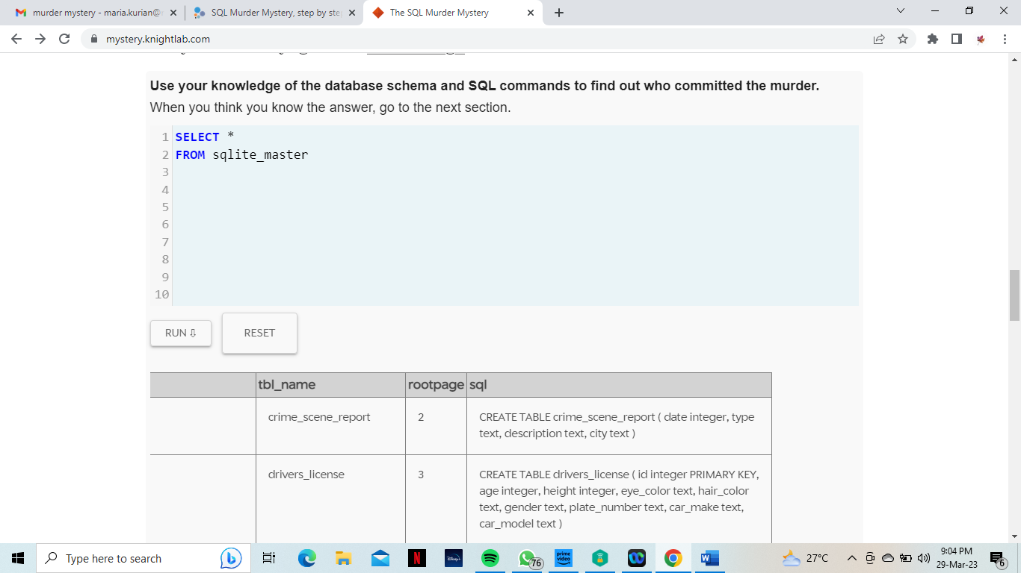

| **type** | **name** | **tbl_name** | **rootpage** | **sql** |
| --- | --- | --- | --- | --- |
| table | crime_scene_report | crime_scene_report | 2 | CREATE TABLE crime_scene_report ( date integer, type text, description text, city text ) |
| table | drivers_license | drivers_license | 3 | CREATE TABLE drivers_license ( id integer PRIMARY KEY, age integer, height integer, eye_color text, hair_color text, gender text, plate_number text, car_make text, car_model text ) |
| table | facebook_event_checkin | facebook_event_checkin | 5 | CREATE TABLE facebook_event_checkin ( person_id integer, event_id integer, event_name text, date integer, FOREIGN KEY (person_id) REFERENCES person(id) ) |
| table | interview | interview | 6 | CREATE TABLE interview ( person_id integer, transcript text, FOREIGN KEY (person_id) REFERENCES person(id) ) |
| table | get_fit_now_member | get_fit_now_member | 7 | CREATE TABLE get_fit_now_member ( id text PRIMARY KEY, person_id integer, name text, membership_start_date integer, membership_status text, FOREIGN KEY (person_id) REFERENCES person(id) ) |
| index | sqlite_autoindex_get_fit_now_member_1 | get_fit_now_member | 8 | null |
| table | get_fit_now_check_in | get_fit_now_check_in | 9 | CREATE TABLE get_fit_now_check_in ( membership_id text, check_in_date integer, check_in_time integer, check_out_time integer, FOREIGN KEY (membership_id) REFERENCES get_fit_now_member(id) ) |
| table | solution | solution | 11 | CREATE TABLE solution ( user integer, value text ) |
| trigger | check_solution | solution | 0 | CREATE TRIGGER check_solution AFTER INSERT ON solution WHEN new.user==1 BEGIN DELETE FROM solution; INSERT INTO solution VALUES (0, CASE WHEN hex(new.value)=='4A6572656D7920426F77657273' THEN "Congrats, you found the murderer! But wait, there's more... If you think you're up for a challenge, try querying the interview transcript of the murderer to find the real villain behind this crime. If you feel especially confident in your SQL skills, try to complete this final step with no more than 2 queries. Use this same INSERT statement with your new suspect to check your answer." WHEN hex(new.value)=='4D6972616E6461205072696573746C79' THEN "Congrats, you found the brains behind the murder! Everyone in SQL City hails you as the greatest SQL detective of all time. Time to break out the champagne!" ELSE "That's not the right person. Try again!" END ); END |
| table | income | income | 10 | CREATE TABLE income (ssn CHAR PRIMARY KEY, annual_income integer) |
| index | sqlite_autoindex_income_1 | income | 683 | null |
| table | person | person | 4 | CREATE TABLE person (id integer PRIMARY KEY, name text, license_id integer, address_number integer, address_street_name text, ssn CHAR REFERENCES income (ssn), FOREIGN KEY (license_id) REFERENCES drivers_license (id)) |

**Step 2:**

**SELECT \***

**FROM**

**crime_scene_report**

**where city=="SQL City"**

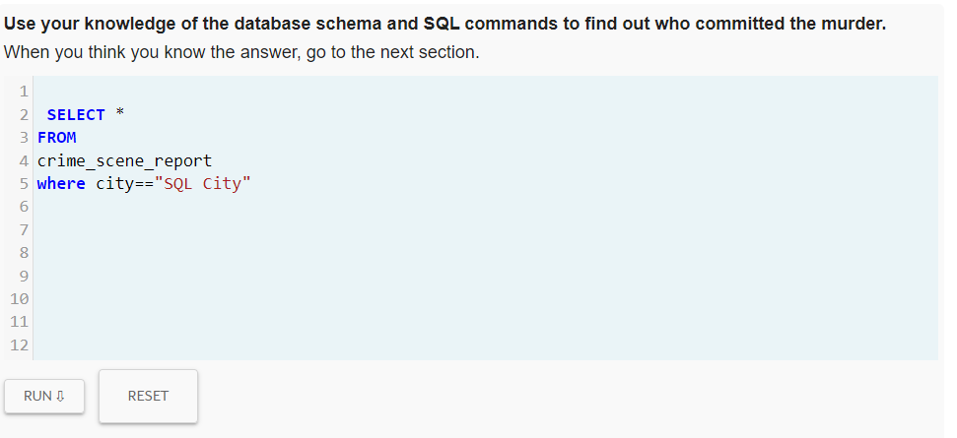

| **date** | **type** | **description** | **city** |
| --- | --- | --- | --- |
| 20180215 | murder | REDACTED REDACTED REDACTED | SQL City |
| 20180215 | murder | Someone killed the guard! He took an arrow to the knee! | SQL City |
| 20170712 | theft | A lone hunter stalks the night, firing arrows into the Darkness. There is no hiding, no escape. In the distance, the beast falters, tethered to the void. The killing blow comes without hesitation, without mercy. | SQL City |
| 20170820 | arson | Wield the Hammer of Sol with honor, Titan, it is a thing of legend, both past and future. | SQL City |
| 20171110 | robbery | The Gjallarhorn shoulder-mounted rocket system was forged from the armor of Guardians who fell at the Twilight Gap. Gifted to the survivors of that terrible battle, the Gjallarhorn is seen as a symbol of honor and survival. | SQL City |
| 20180103 | bribery | Apparently, Cayde thought it necessary to expose this extremely rare vegetable to a Hive summoning ritual. | SQL City |
| 20180115 | assault | Hamilton: Lee, do you yield? Burr: You shot him in the side! Yes he yields! | SQL City |
| 20180115 | assault | Report Not Found | SQL City |
| 20180115 | murder | Security footage shows that there were 2 witnesses. The first witness lives at the last house on "Northwestern Dr". The second witness, named Annabel, lives somewhere on "Franklin Ave". |  |

**Step 3:**

**SELECT \***

**FROM crime_scene_report**

**where city=="SQL City" and date=="20180115"**

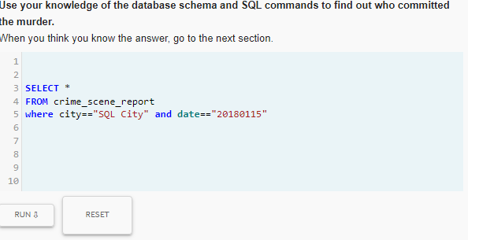

| **date** | **type** | **description** | **city** |
| --- | --- | --- | --- |
| 20180115 | assault | Hamilton: Lee, do you yield? Burr: You shot him in the side! Yes he yields! | SQL City |
| 20180115 | assault | Report Not Found | SQL City |
| 20180115 | murder | Security footage shows that there were 2 witnesses. The first witness lives at the last house on "Northwestern Dr". The second witness, named Annabel, lives somewhere on "Franklin Ave". |  |

**Step 4:**

**SELECT \***

**FROM person**

**where address_street_name=="Northwestern Dr"**

**order by address_number desc**

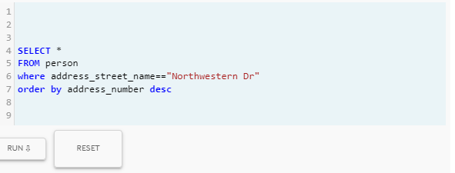

|  |  |  |  |  |  |
| --- | --- | --- | --- | --- | --- |
| **id** | **name** | **license_id** | **address_number** | **address_street_name** | **ssn** |
| **14887** | **Morty Schapiro** | **118009** | **4919** | **Northwestern Dr** | **111564949** |
| **17729** | **Lasonya Wildey** | **439686** | **3824** | **Northwestern Dr** | **917817122** |
| **53890** | **Sophie Tiberio** | **957671** | **3755** | **Northwestern Dr** | **442830147** |
| **73368** | **Torie Thalmann** | **773862** | **3697** | **Northwestern Dr** | **341559436** |
| **96595** | **Coretta Cubie** | **303645** | **3631** | **Northwestern Dr** | **378403829** |
| **19420** | **Cody Schiel** | **890431** | **3524** | **Northwestern Dr** | **947110049** |
| **93509** | **Emmitt Aceuedo** | **916706** | **3491** | **Northwestern Dr** | **979073160** |
| **87456** | **Leonora Wolfsberger** | **215868** | **3483** | **Northwestern Dr** | **565203106** |
| **36378** | **Freddie Ellzey** | **267882** | **3449** | **Northwestern Dr** | **474117596** |
| **53076** | **Boris Bijou** | **664914** | **3327** | **Northwestern Dr** | **401191868** |
| **28360** | **Rashad Cascone** | **924517** | **3212** | **Northwestern Dr** | **838907424** |
| **23044** | **Val Portlock** | **924989** | **3143** | **Northwestern Dr** | **100593316** |
| **51114** | **Christena Saffell** | **814284** | **3055** | **Northwestern Dr** | **247657547** |
| **68690** | **Yer Modest** | **852404** | **3046** | **Northwestern Dr** | **419238039** |
| **44004** | **Alison Eska** | **327797** | **2951** | **Northwestern Dr** | **306417867** |
| **98593** | **Jonah Toner** | **578982** | **2947** | **Northwestern Dr** | **745853548** |
| **59307** | **Cyril Yongue** | **753524** | **2903** | **Northwestern Dr** | **866057839** |
| **34155** | **Allyson Lazenson** | **814209** | **2840** | **Northwestern Dr** | **991150469** |
| **90397** | **Dionna Kranwinkle** | **797260** | **2678** | **Northwestern Dr** | **278964807** |
| **54564** | **Sammie Sengun** | **217286** | **2590** | **Northwestern Dr** | **848854310** |
| **53699** | **Christian Pagano** | **628433** | **2585** | **Northwestern Dr** | **644772304** |
| **34352** | **Vincenza Burkhardt** | **436470** | **2512** | **Northwestern Dr** | **197913046** |
| **80921** | **Donovan Yackley** | **222395** | **2386** | **Northwestern Dr** | **515049359** |
| **96178** | **Galina Khuu** | **450248** | **2183** | **Northwestern Dr** | **398518185** |
| **81885** | **Kurtis Masuda** | **934201** | **2108** | **Northwestern Dr** | **201272595** |
| **88423** | **Teri Ehrich** | **510876** | **1879** | **Northwestern Dr** | **248637345** |
| **51552** | **Bonita Knie** | **764124** | **1726** | **Northwestern Dr** | **597137908** |
| **72076** | **Courtney Bordeaux** | **324614** | **1707** | **Northwestern Dr** | **347966356** |
| **81052** | **Calvin Czelusniak** | **471483** | **1516** | **Northwestern Dr** | **657531837** |
| **71924** | **Laurie Scronce** | **774116** | **1418** | **Northwestern Dr** | **254883636** |
| **23960** | **Kristopher Lagerberg** | **658777** | **1392** | **Northwestern Dr** | **492912529** |
| **70485** | **Andera Kostelecky** | **354822** | **1252** | **Northwestern Dr** | **787423012** |
| **22239** | **Dusty Sigafus** | **710517** | **1125** | **Northwestern Dr** | **724386723** |
| **18376** | **Josh Shi** | **653712** | **1091** | **Northwestern Dr** | **193899001** |
| **29608** | **Willetta Lurvey** | **800568** | **1028** | **Northwestern Dr** | **843751378** |
| **33415** | **Homer Simpson** | **108392** | **981** | **Northwestern Dr** | **871392019** |
| **55130** | **Shiloh Huntoon** | **472118** | **951** | **Northwestern Dr** | **826647644** |
| **44542** | **Ivory Mcgrevey** | **873842** | **897** | **Northwestern Dr** | **988557407** |
| **99826** | **Ivy Kazarian** | **994470** | **892** | **Northwestern Dr** | **208359813** |
| **25615** | **Olevia Morena** | **388477** | **812** | **Northwestern Dr** | **962831331** |
| **40760** | **Renata Faver** | **976650** | **745** | **Northwestern Dr** | **547572040** |
| **10010** | **Muoi Cary** | **385336** | **741** | **Northwestern Dr** | **828638512** |
| **39688** | **Abe Roeker** | **537445** | **689** | **Northwestern Dr** | **438969447** |
| **26758** | **Angelena Billman** | **942074** | **629** | **Northwestern Dr** | **341854756** |
| **75484** | **Del Tacderen** | **447887** | **607** | **Northwestern Dr** | **243821337** |
| **12711** | **Norman Apolito** | **667757** | **599** | **Northwestern Dr** | **778264744** |
| **85280** | **Donn Duin** | **569122** | **540** | **Northwestern Dr** | **613873810** |
| **40336** | **Fredia Billeter** | **251082** | **404** | **Northwestern Dr** | **108056488** |
| **15171** | **Weldon Penso** | **336999** | **311** | **Northwestern Dr** | **131379495** |
| **89906** | **Kinsey Erickson** | **510019** | **309** | **Northwestern Dr** | **635287661** |

**Step 5:**

**SELECT \***

**FROM person**

**where name like 'Annabel %'**

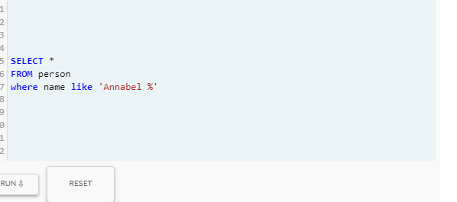

|  |
| --- |
| **Idname license_id address_number address_street_name ssn** |
| **16371 Annabel Miller 490173 103 Franklin Ave 318771143** |

**Step 6:**

**SELECT \***

**FROM person P**

**left join interview I**

**on P.id=I.person_id**

**where id=="14887" or id=="16371"**

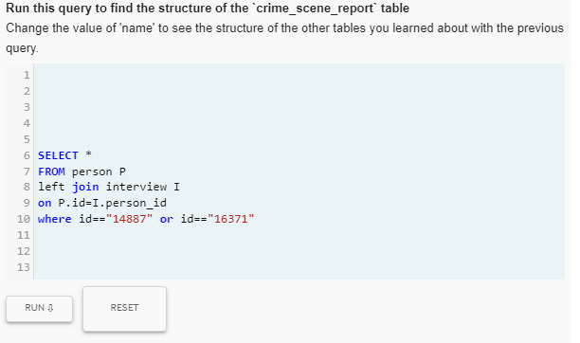

| **id** | **name** | **license_id** | **address_number** | **address_street_name** | **ssn** | **person_id** | **transcript** |
| --- | --- | --- | --- | --- | --- | --- | --- |
| 14887 | Morty Schapiro | 118009 | 4919 | Northwestern Dr | 111564949 | 14887 | I heard a gunshot and then saw a man run out. He had a "Get Fit Now Gym" bag. The membership number on the bag started with "48Z". Only gold members have those bags. The man got into a car with a plate that included "H42W". |
| 16371 | Annabel Miller | 490173 | 103 | Franklin Ave | 318771143 | 16371 | I saw the murder happen, and I recognized the killer from my gym when I was working out last week on January the 9th. |

**Step 7:**

**select \***

**from person P**

**left join drivers_license D**

**on P.license_id= D.id**

**where plate_number like '%H42W%'**

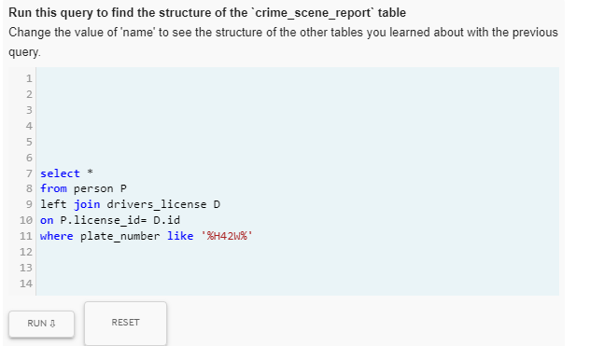

| **id** | | **name** | | **license_id** | **address_number** | **address_street_name** | | **ssn** | **id** | | **age** | | **height** | | **eye_color** | | **hair_color** | | **gender** | | **plate_number** | | **car_make** | | **car_model** | |
| --- | --- | --- | --- | --- | --- | --- | --- | --- | --- | --- | --- | --- | --- | --- | --- | --- | --- | --- | --- | --- | --- | --- | --- | --- | --- | --- |
| 51739 | Tushar Chandra | | 664760 | 312 | Phi St | | 137882671 | 664760 | | 21 | | 71 | | black | | black | | male | | 4H42WR | | Nissan | | Altima | |
| 67318 | Jeremy Bowers | | 423327 | 530 | Washington Pl, Apt 3A | | 871539279 | 423327 | | 30 | | 70 | | brown | | brown | | male | | 0H42W2 | | Chevrolet | | Spark LS | |
| 78193 | Maxine Whitely | | 183779 | 110 | Fisk Rd | | 137882671 | 183779 | | 21 | | 65 | | blue | | blonde | | female | | H42W0X | | Toyota | | Prius | |

**Step 8:**

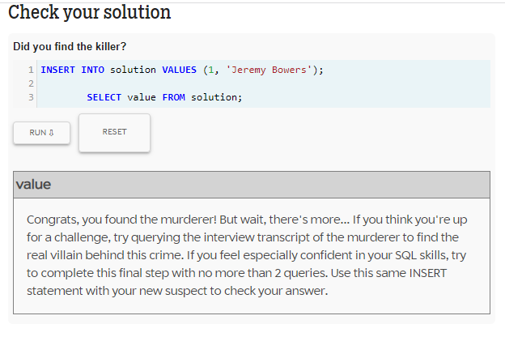

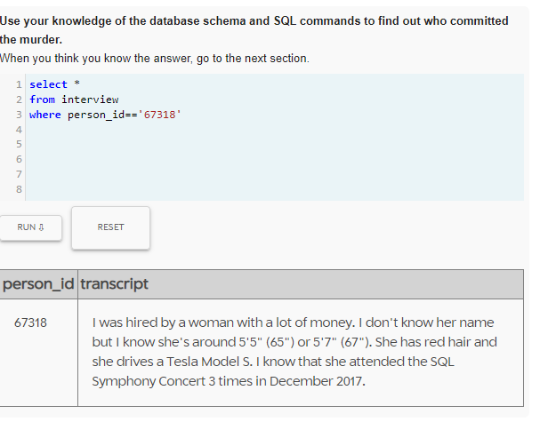

**person_id event_id event_name date id name license_id address_number**

**address_street_name ssn id age height eye_color hair_color gender**

**plate_number car_make car_model**

**99716 1143 SQL Symphony Concert 20171206 99716 Miranda Priestly202298 1883**

**Golden Ave 987756388 202298 68 66 green red female 500123**

**Tesla Model S**

**99716 1143 SQL Symphony Concert 20171212 99716 Miranda Priestly202298 1883**

**Golden Ave 987756388 202298 68 66 green red female 500123**

**Tesla Model S**

**99716 1143 SQL Symphony Concert 20171229 99716 Miranda Priestly202298 1883**

**Golden Ave 987756388 202298 68 66 green red female 500123**

**Tesla Model S**

**Step 9:**

**SELECT\***

**FROM person P**

**INNER join drivers_license as L**

**ON L. id= P.license_id**

**INNER JOIN income as I**

**ON I.ssn = P.ssn**

**WHERE L.gender = "female"**

**AND L.car_make = "Tesla"**

**AND L.car_model = "Model S"**

**AND L.height > 65**

**AND L.height < 67**

**AND L.hair_color = "red"**

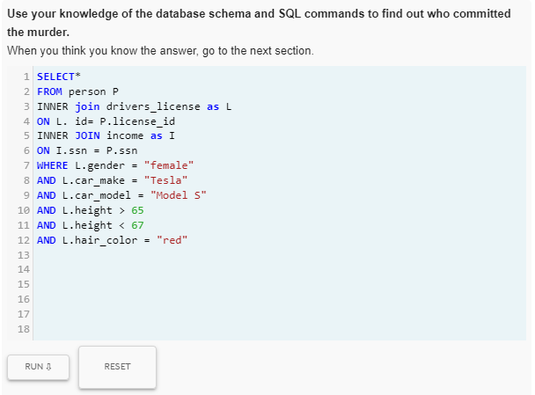

|  |  |  |
| --- | --- | --- |
| |  | | --- | | **Idname license_idaddress_numberaddress_street_namessnidageheighteye_colorhair_colorgenderplate_numbercar_makecar_modelssnannual_income** | | 99716Miranda Priestly2022981883Golden Ave9877563882022986866greenredfemale500123TeslaModel S987756388310000 | |

**Step 10:**

